Algebra 2 Syllabus Common Core

Text Book Resource (additional resources may be incorporated)
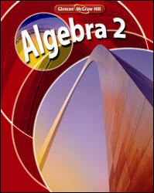

Linear Equations, Inequalities and Systems: Chapters 1, 2, 3, 4

Quadratic, Polynomial and Radical Equations: Chapters 5, 6, 7

Rational, Exponential, Logarithmic Functions and Properties of Functions: Chapters 8, 9

Sequences and Series: Chapter 11

Probability, Data Analysis and Statistics: Chapter 12

Conic Sections: Chapter 10

Trigonometry and Trigonometry Functions: Chapters 13, 14

